INFORMACIÓN BÁSICA
NOMBRE DE LA PRÁCTICA:  Work guide 6 | PRÁCTICA No.:  6
ASIGNATURA:
Digital image processing
TEMA DE LA PRÁCTICA:
Texture fundamentals LBP and wavelet

LABORATORIO A UTILIZAR:

Systems Room
CONTENIDO DE LA GUÍA

OBJETIVOS.
- To perform texture analysis LBP with haralick texture measures and classify .

INTRODUCCIÓN

LOCAL BINARY PATTERNS
The local binary patterns (LBP) was a technique development to complement contrast characterization, later this was used as a texture detection method. The LBP opertaor is defined as invariant measure of gray scale taken from the classic method of boundary analysis. The original algorithm was proposed by Harwood y Ojala (1993) [1].
The LBP feature vector, in its simplest form, is created in the following manner:
- Divide the examined window into cells (see figure 1).
- For each pixel in a cell, compare the pixel to each of its 8 neighbors (on its left-top, left-middle, left-bottom, right-top, etc.). Follow the pixels along a circle, in. clockwise or counter-clockwise.
- Where the center pixel's value is greater than the neighbor's value, write "0". Otherwise, write "1". This gives an 8-digit binary number (which is usually converted to decimal for convenience).
- Compute the histogram, over the cell, of the frequency of each "number" occurring (for example, each combination of which pixels are smaller and which are greater than the center). This histogram can be seen as a 256-dimensional feature vector.
- Optionally normalize the histogram.
- Concatenate (normalized) histograms of all cells. This gives a feature vector for the entire window.

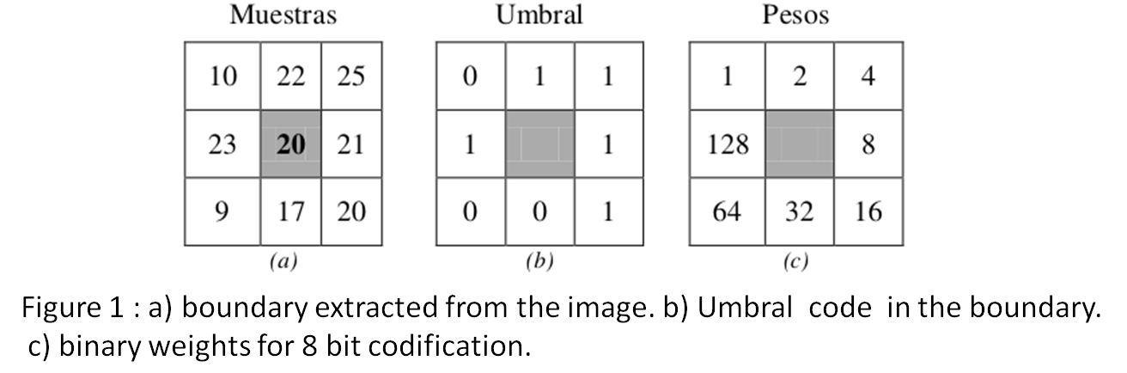
To see the the result in image terms the central pixel in gray in figure 1, corresponds to sum of each weight in this case LBP(x,y)= 2 + 4+8+16+128.

METODOLOGÍA
- In the matlab help read about the correct way of partitioning a sample data set using cv parttion command.
- In the matlab help read about how to classify between classes using the KNN algorithm.
- Using the Artificial data set given by your teacher apply the LBP codification and obtain the LBP histogram as VCK vector.
- Using the Artificial data set given by your teacher apply the LBP codification and obtain the LBP image and compute the haralick texture features as the VCK vector.
- Run the KNN classifier with the propossed parameters given by your teacher.
MATERIALES, EQUIPOS Y REACTIVOS A UTILIZAR (Indicar las cantidades)

Materiales y Equipos | Reactivos | Materiales Estudiante
Matlab (image processing toolbox)

PRECAUCIONES Y MANEJO DE MATERIALES Y EQUIPOS. CONSULTA DE EQUIPO ESPECIALIZADO.

Please take care of the computer assigned to you.

Exercises

- Implement a function that codifies that codifies an image using the LBP operator for 8 bits.
- Apply the codification over all the data set. Extract t the LBP histogram as VCK and the Haralick texture feature as a second VCK vector.
- Split the Data set in two. Train an d test set.
- Classify the two classes given by your teacher.
- Use classperform command in matlab to obtain the number of false positives, correct positives, False negatives and correct negatives.

BIBLIOGRAFÍA RECOMENDADA.

[1] Harwood D, Ojala T, Pietikäinen M, Kelman S & Davis S, Texture
classification by center-symmetric auto-correlation, using Kullback
discrimination of distributions. Technical report, Computer Vision
Laboratory, Center for Automation Research, University of Maryland,
College Park, Maryland. CAR-TR-678, 1993.

[2] Digital Image Processing,
Gonzales, R.C., Woods, R.E
2ed, Prentice Hall, 2002

consultada 17/09/2016.

ELABORÓ  (Personas que elaboraron la guía) | REVISÓ  (Director de Programa o Área) | APROBÓ  (Laboratorios)
Firma Jorge Andres Alvarez Triana  Nombre :  Fecha:8/09/2016 | Firma  Nombre :  Fecha: | Firma  Nombre :  Fecha:

INFORME DE LABORATORIO
(Para elaborar por el Estudiante)
ESTUDIANTES: | GRUPO:
ESTUDIANTES: | NOTA:

CARRERA:

Formule tres objetivos que desee cumplir con la Práctica de Laboratorio
El estudiante formulará desde su conocimiento los objetivos para la realización de la práctica

Elabore un Mapa conceptual del tema a tratar en la Práctica de Laboratorio.

RESULTADOS
Incluir tablas, diagramas en la que los estudiantes puedan ir consignando los datos y observaciones obtenidos en la práctica

CAUSAS DE ERROR Y ACCIONES PARA OBTENER MEJORES RESULTADOS:

El estudiante formulara las posibles causas de error comparando sus resultados experimentales con los teóricos

CONCLUSIONES

El estudiante realizara una serie enunciados que respondan a los objetivos que el mismo formuló, basados en el desarrollo de la práctica.

APLICACIÓN PROFESIONAL DE LA PRÁCTICA REALIZADA

BIBLIOGRAFIA UTILIZADA
[1] Digital Image Processing,
Gonzales, R.C., Woods, R.E
2ed, Prentice Hall, 2002

